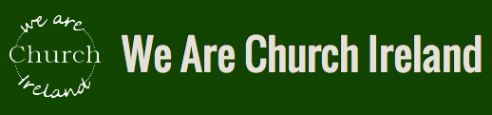

Can Ireland learn from the German Synodal Path?

Prof. Claudia Nothelle and Bishop Matthäus Karrer

Followed by Q & A

7.30 pm Thursday 2nd of February 2023
ZOOM Meeting

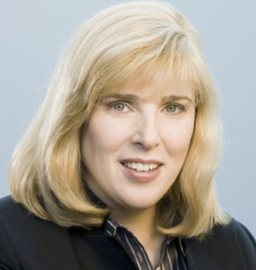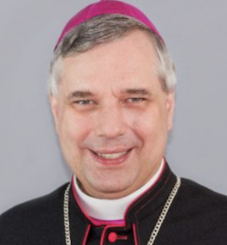

Professor Claudia Nothelle is a Member of the German Synodal Path Assembly. She is Vice-President of the Central Committee of German Catholics. She is Professor of Television Journalism at Hochschule Magdeburg Stendal.

Bishop Matthäus Karrer is a Member of the German Synodal Path Assembly. He is Auxilliary Bishop of the Diocese of Rottenburg-Stuttgart, one of the few dioceses which allow lay people to conduct baptisms.

Please click here to book your FREE ticket on Eventbrite

